STUDENT
NAME
ADRESSCITY
ALGEBRA 1 EXAM-3
ANSWERS
1 .B
2 .C
3. A
4. B
5 .B
6 .D
7. D
8. A
9. A
10 A
11. C
12.A
13.C
14.C
15.D
16A

Q17-18
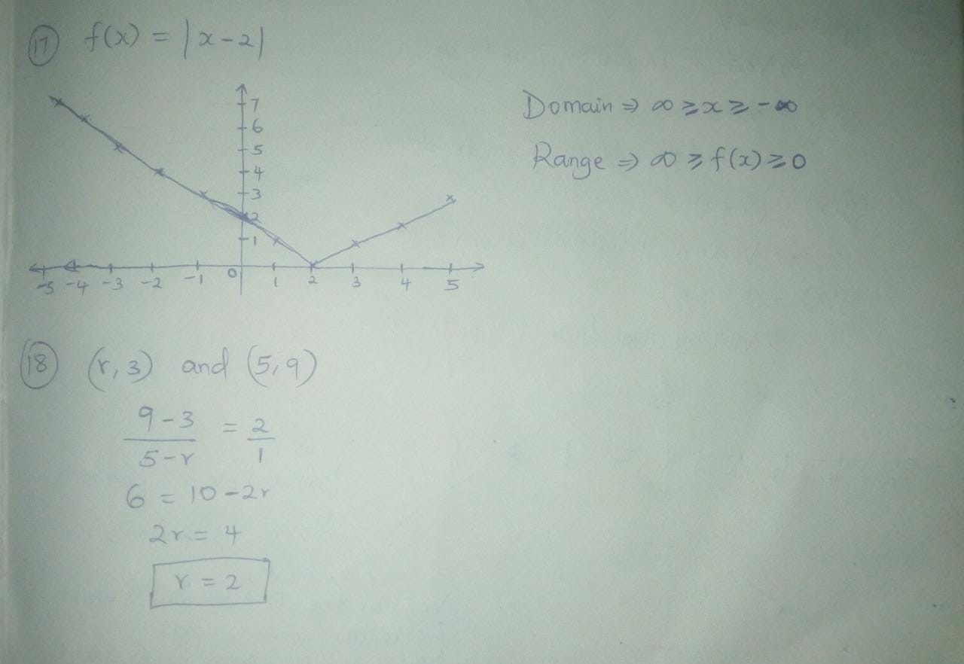

Q 19-Q20.
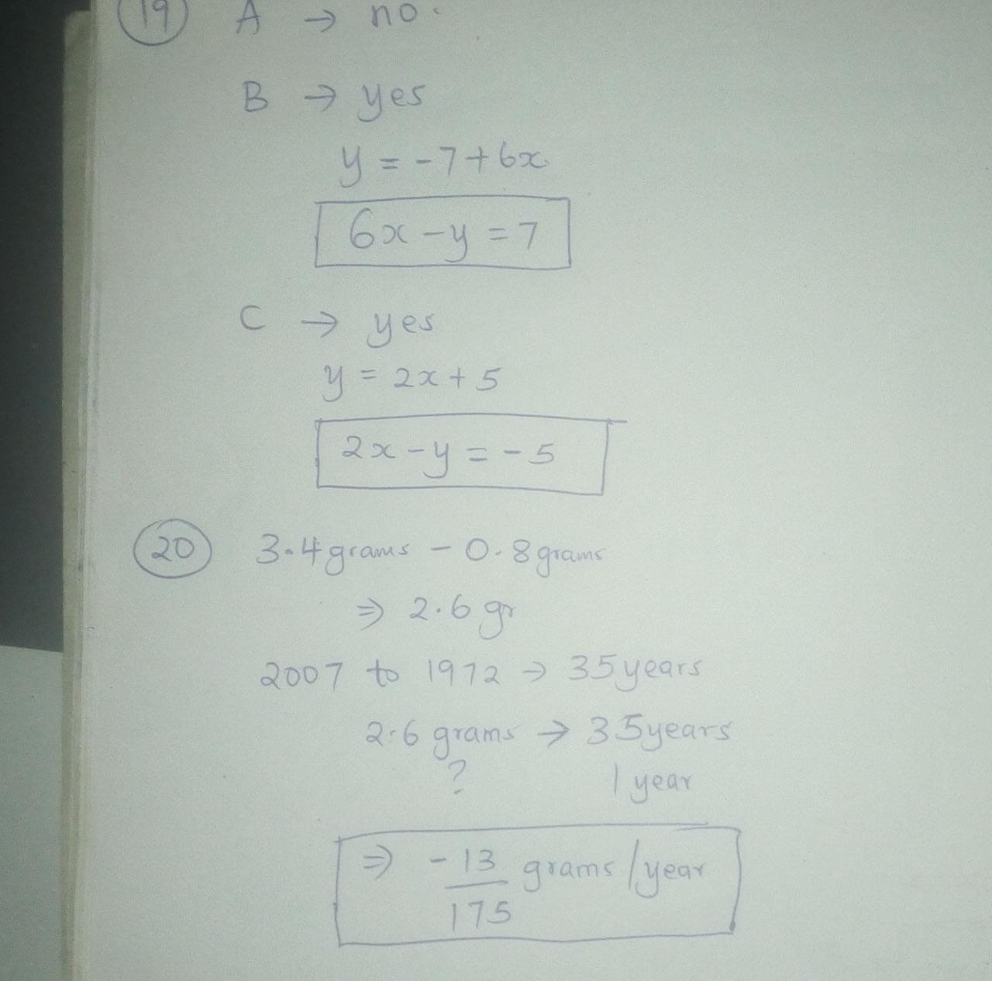

21.& 22
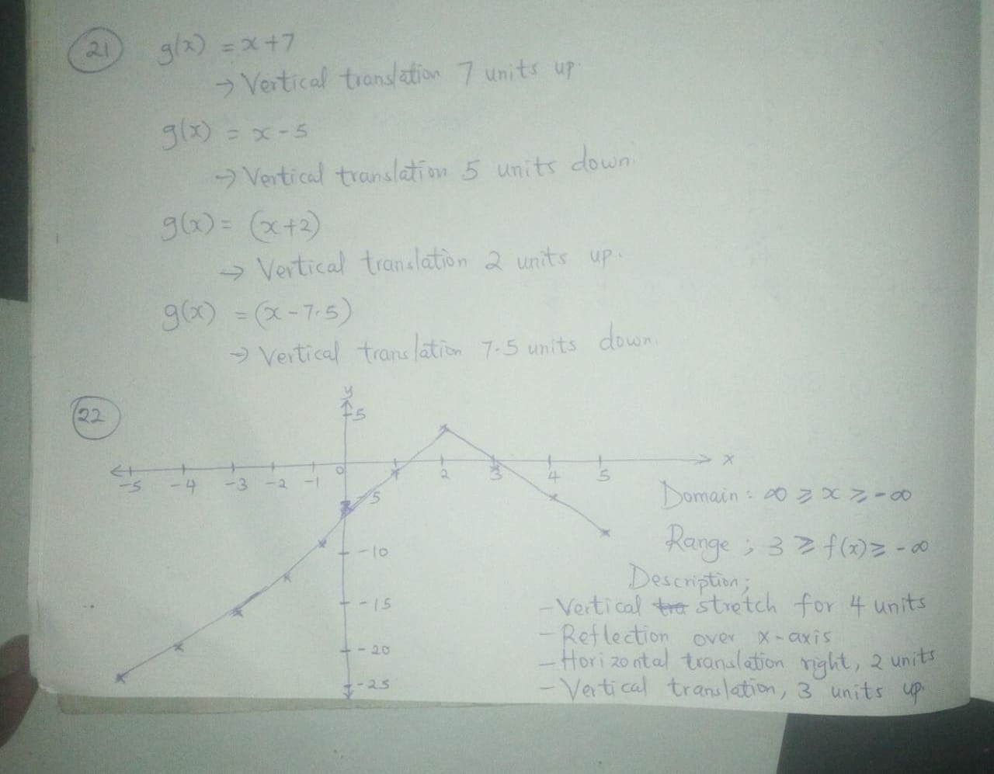
23 , 24 AND 25.
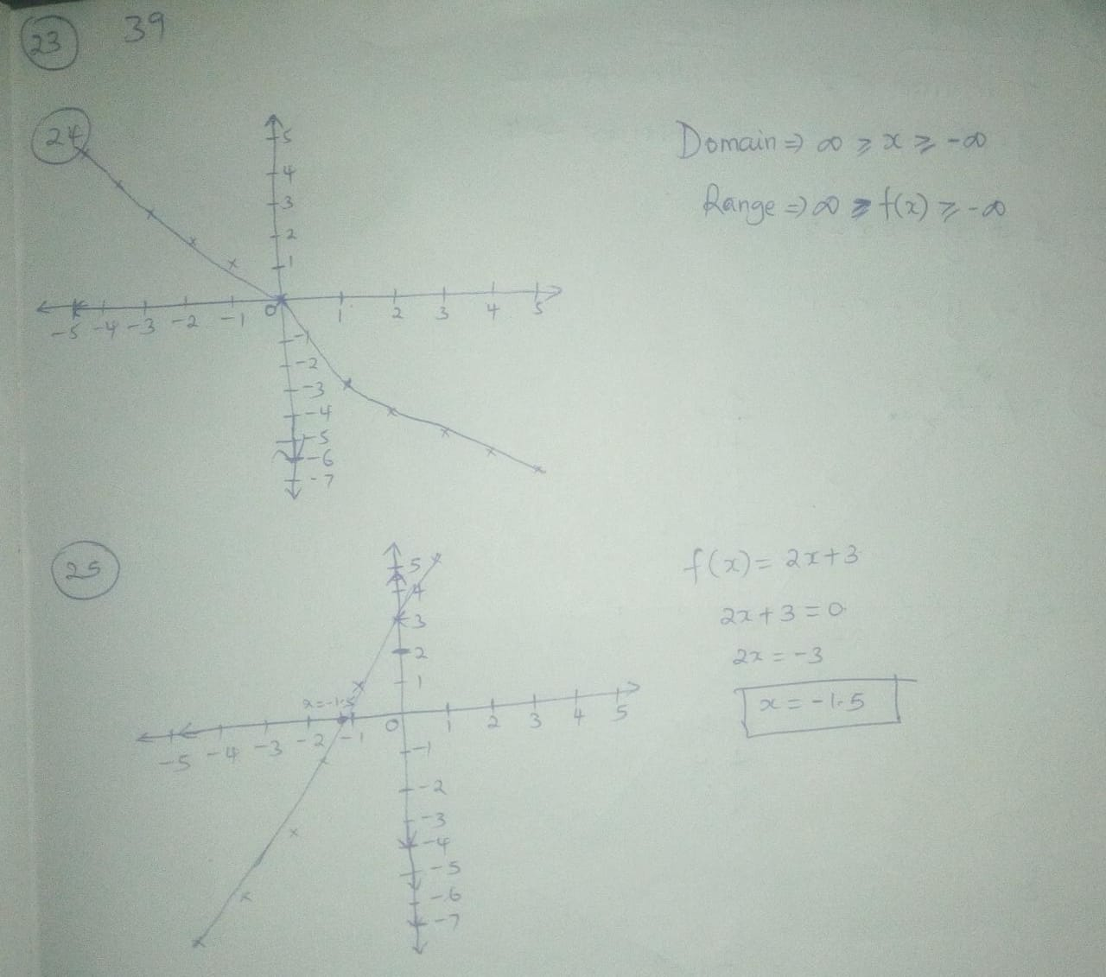

26 AND 27.
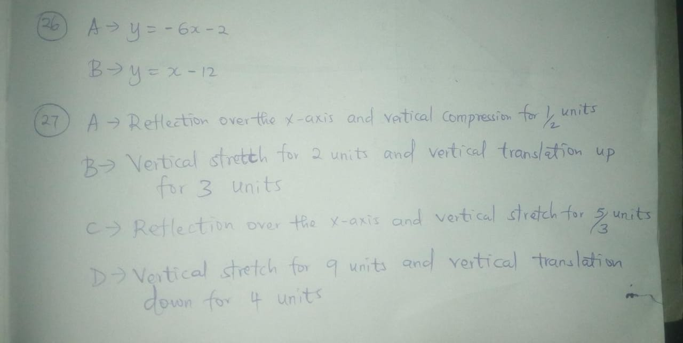
28 AND 29
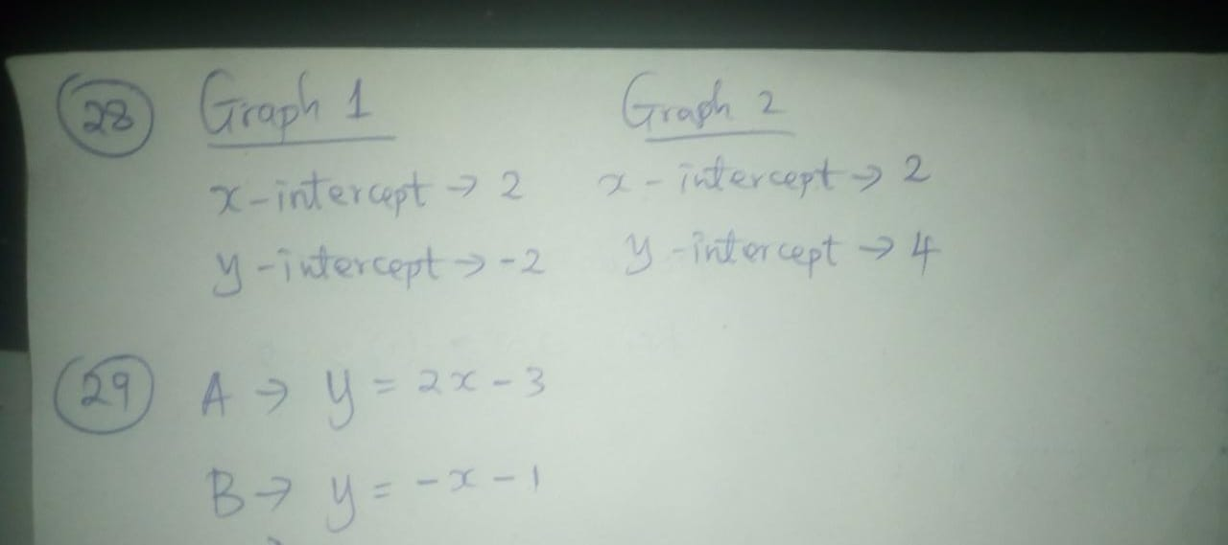

30.
